Pyramid of Pain
DG Interns Hub | Week 1 | TryHackMe Room Writeup

Objective
Understand threat intelligence indicators and the Pyramid of Pain model.

Activity summary
Reviewed the model and completed the room questions.

Key learning
Hashes, IP addresses, domains, network/host artifacts, tools and TTPs.

Evidence
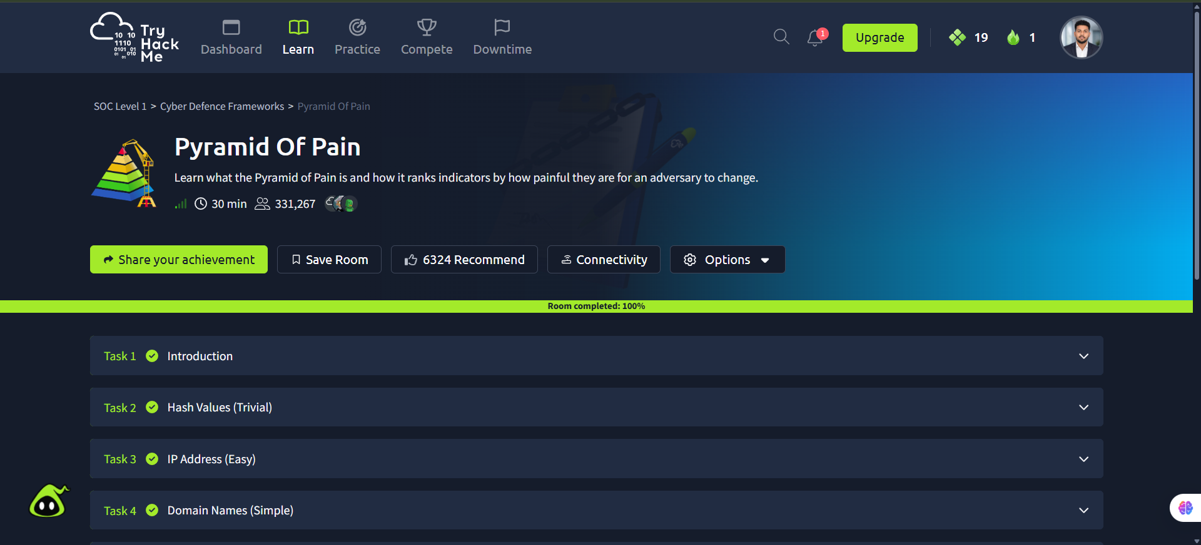
Screenshot: Pyramid_of_Pain.png
Completion screenshot provided; the original step-by-step room answers were not included in the archive.

